|  |  |  |
| --- | --- | --- |
| **Course : (WEB322) -Web Programming Tools and Frameworks** | **Assignment 1 & 2 of 5** | **Contribution:20% of course** |
| **Instructor : Kadeem Best** | **Date Given: June 3rd 2021** | **Date Due: June 23rd 2021** |

**Notes for the Student:** This Assignment is 1 & 2 of five that is designed to give you practical experience in building Dynamic websites and Server-Side Web applications using Node.js and Express.

**Background**: You will need to have access to a code editor. You will also need a thorough understanding of HTML 5, CSS3, Javascript, “Node.JS”, Express and Handlebars.

**Assignment Submission Requirements**

* Submit the link of your GitHub or BitBucket remote repo to Blackboard
  + Ensure that your GitHub was created as a private repo. Then add me as a collaborator so that I can view your project (**kadeembestteaches@gmail.com**)
* Submit the link of your hosted Heroku project in Blackboard.
* **If your application is not pushed to GitHub or BitBucket, it will not be marked.**
* If your web application does not function or work on Heroku, it will not be marked.
* Marks will be deducted for any projects committed to GitHub or BitBucket after the deadline date.
* You are also required to submit a report. The report must be in pdf format and must contain the following :-
  + A cover page.
  + A table of contents.
  + Screenshots of your website, with relevant descriptions, detailing whether the functionality was met or not met, as specified below.
  + References of any libraries and images use
* **You must demo this assignment to me. Failure to demo this project would result in 0 grade.**

## **Assignment Regulations**

* **This assignment must be done individually.**
* **Please review Seneca’s policies on Academic Integrity, specifically:**

*“Each student should be aware of the College's policy regarding Cheating and Plagiarism. Seneca's Academic Policy will be strictly enforced.To support academic honesty at Seneca College, all work submitted by students may be reviewed for authenticity and originality, utilizing software tools and third party services. Please visit the Academic Honesty site on http://library.senecacollege.ca for further information regarding cheating and plagiarism policies and procedures.  
.”* ***Thus, ensure that your code or any part of it is not duplicated by another student(s). This will result in a percentage of zero (0%) assigned to all parties involved.***

**Technical Requirements**

* All back-end functionality **MUST** be done using **Node JS and Express**.
* Your views **MUST** be created with **Express-Handlebars**

ASSIGNMENT 1 (10%)

# **Detailed App Specification**

You have been contracted as a Full Stack developer to develop a vacation destination property booking web application. See similar websites for inspiration :

* <https://www.expedia.ca/>
* <https://ca.hotels.com/>
* <https://www.booking.com/>

The implementation of the entire functionality for this web application will be spanned over 5 Assignments.

In this assignment, you will **ONLY** focus on building your views for your web application. **No database connectivity, validation or responsive design is required for Assignment 1.**

|  |
| --- |
| REMINDER:  All back-end functionality **MUST** be done using **Node JS and Express**.  Your views **MUST** be created with **Express-Handlebars** |

Specifically, you are **ONLY** required to implement the following :

# Features

# 

# Express web server set up

Create an Express web server that listens to incoming HTTP requests.

# 

# Route Handlers Implementation

Ensure that you create route handlers that will direct users to specific views when they navigate to the following routes:

* Home Page
* Vacation Destination Property Listing Page
* Vacation Destination Property Details Page
* Customer Registration
* Login

## Home Page

You are required to build a **well designed** home page that consists of the following sections:

* **Header -** The header **MUST** contain the logo of your website and could contain the navigation bar and any other content you deem necessary.
* **A Navigation bar** - The navigation bar can be within the header or defined as an entirely new area. It **MUST** have links that navigate visitors to a sign up page and the login page. Please note, **instead of creating a separate page for the sign up page and the login page, you can render it as modal pop-up boxes(this is your choice)**.

**Figure 1.1**



* **Hero Section** - This section must display banners and images highlighting the most in demand vacation packages now. This should be implemented as an image carousel

**Figure 1.2**



**See below, some examples of free Javascript and CSS Image Carousel Libraries**

* + <https://splidejs.com/>
  + <https://getbootstrap.com/docs/4.0/components/carousel/>
  + <https://css-tricks.com/css-only-carousel/>
* **Browse By Property Type Section**- This section must display at least four (3 -6) property types, as shown in figure 1.3. Each property type must have an image and must be pulled from the fake database.

**Figure 1.3**

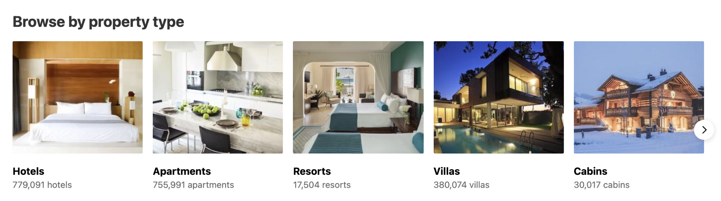

* **Browse By Location Type Section** - This section must display at least four (3 -6) locations, as shown in figure 1.3. Each location must have an image and each location must be pulled from the fake database.

**Figure 1.4**

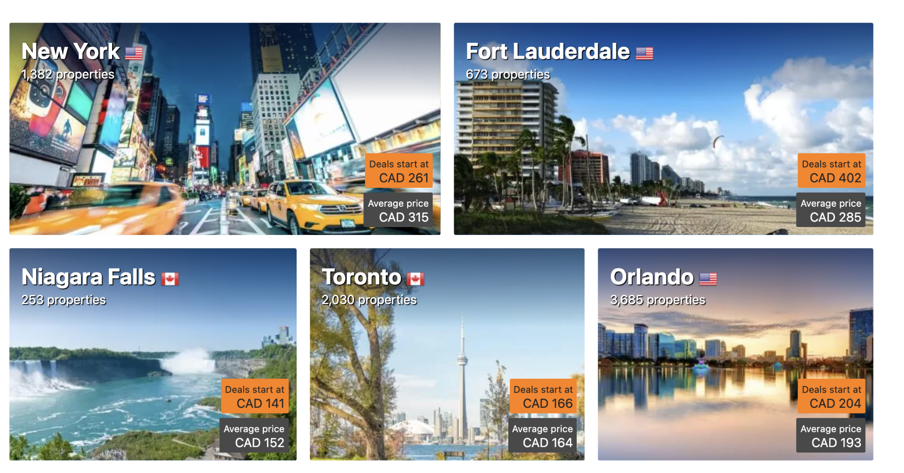

Please note, the data for the destination properties must be pulled from a “fake database.” You are to represent the fake database as an array of objects, declared as a module (a separate JavaScript file).

Each vacation destination property must have :

* Title
* Location (Toronto, Texas, Trinidad and Tobago, New York,etc)
* Star rating (range 1 to 5)
* Type (Cabin, Hotel, Room, House, etc)
* A Small and Large Poster Image
* Price to rent the destination property per day
* Details (This should display information about the rooms and facilities available. Example :3 bedrooms , 1 living room,­ 1 bathroom, 4 beds (1 twin, 1 full, 1 king, 1 sofa bed)
* **Content Section(s)** - These sections **MUST** use a combination of grids, headings and images, with the purpose of highlighting the company’s services and/or exciting vacation deals and packages. Figure 1.5 & 1.6 are some examples:

**Figure 1.5**

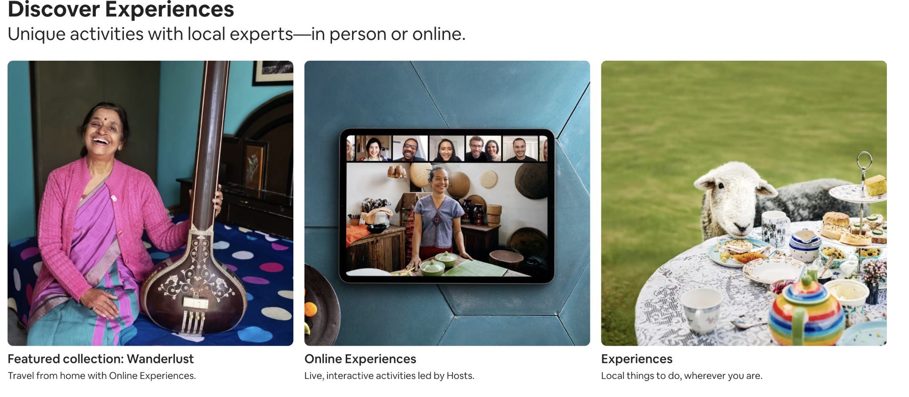

**Figure 1.6**

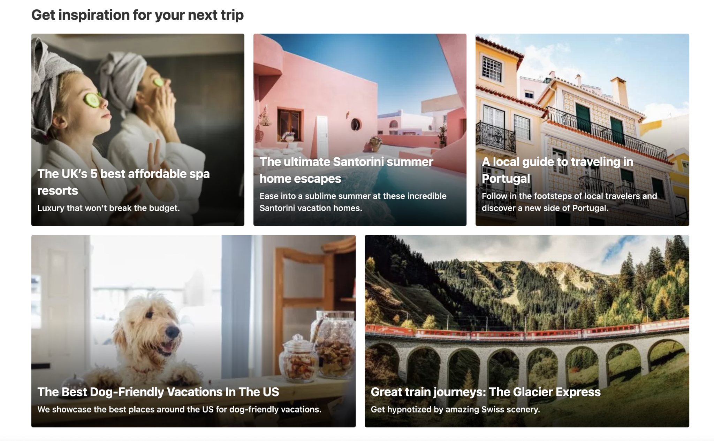

* Footer - This section **must** include footer menu items, social media links, and any other information you deem necessary.

**Figure 1.7**

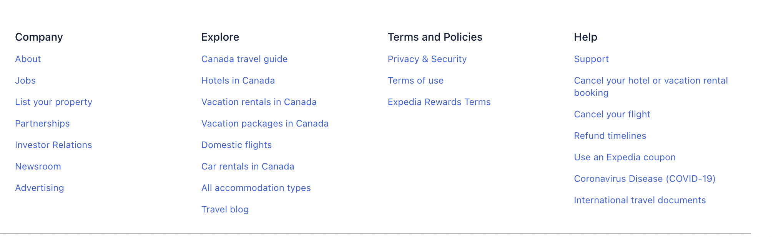

## 

## Vacation Destination Property Listing page

You are required to build a **well designed** vacation destination property listing page. This page must list, at least, **12 sample vacation destination properties.**

**Figure 1.8 (Vacation Destination Property Page)**

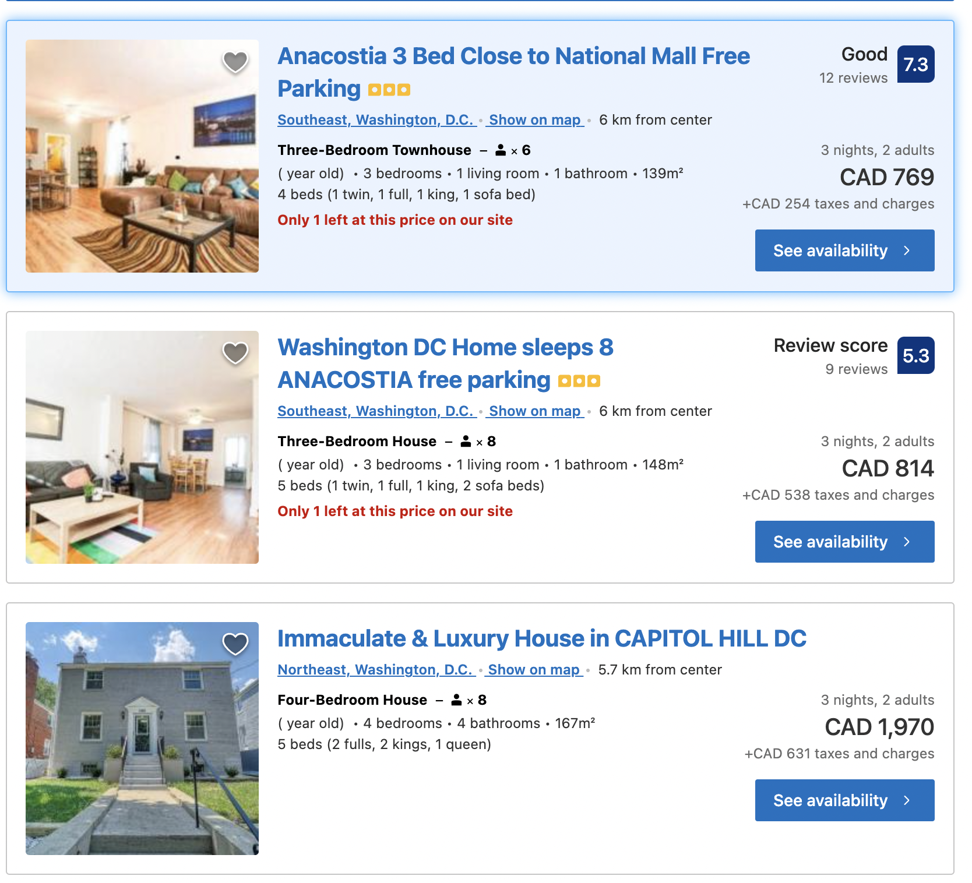

This page should pull **ALL** vacation destination property from the “fake database”(separate module file) mentioned above. Note, this page should only display the image, title, price and location of each vacation destination and it should be clickable.

When a user clicks on a respective image, the user is navigated to the **Vacation Destination Property Details page** for the clicked property. For example, if the user clicks on the “Immaculate & Luxury House in Capitol HILL DC) image, then the user must be navigated to the Details page of said.

## Vacation Destination Property Details Page

You are required to build a **well designed** vacation destination property details page. From the listing page, when a user clicks on a particular property, they should be navigated to this page.

This page should list the title of the property, type, location, rating, details, small poster, large poster, the price to book the property and a button to book it.

**Figure 1.9**

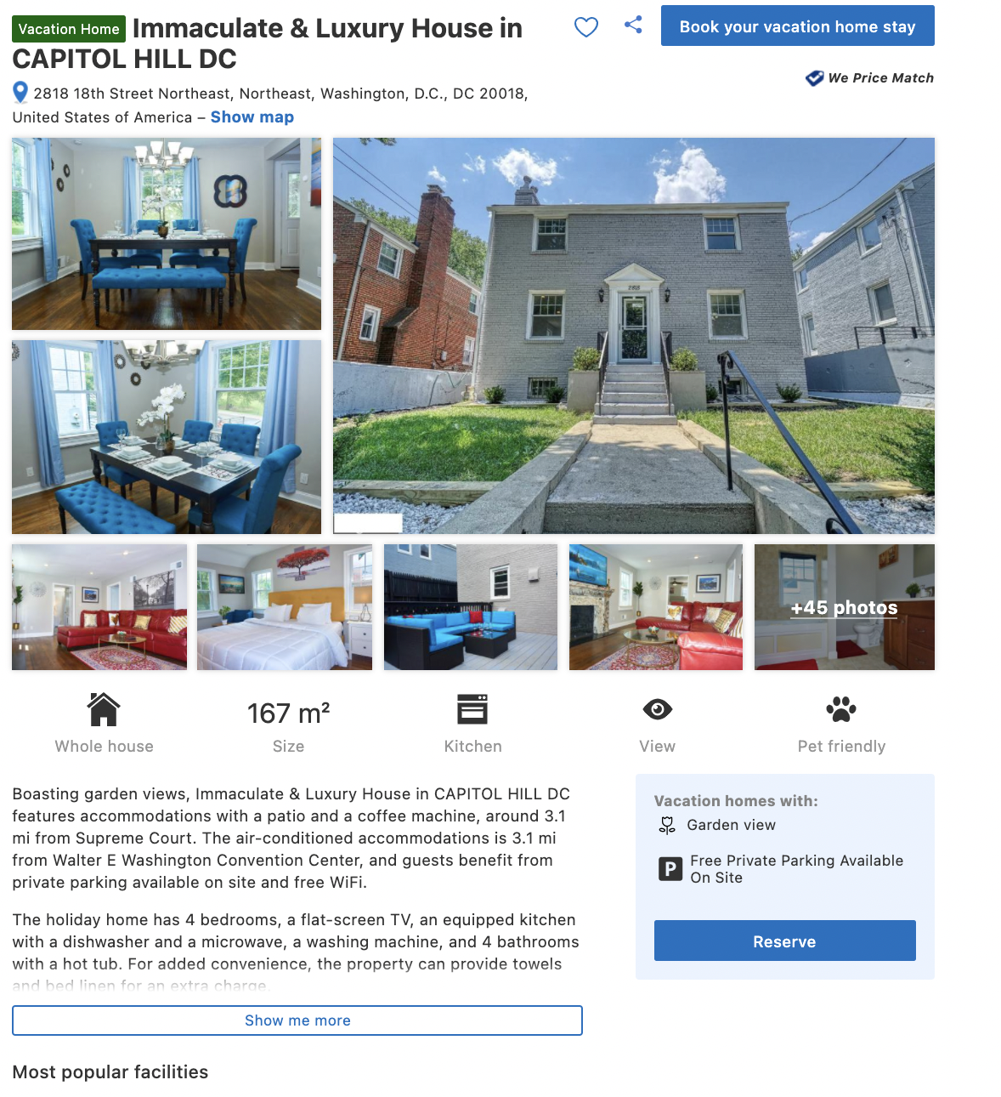

## 

## Registration Page

You are required to build a **well designed** user registration form.. This can be implemented as an entirely new page or as a pop-up modal. In the event you implement this as a new page then you must ensure that the page maintains consistency regarding its structure, header, nav, footer,etc as the home page. Your registration form must capture the user’s first name, last name,email password, confirm password

## Login Page

You are required to build a **well designed** login form (email and password). This can be implemented as an entirely new page or as a pop-up modal. In the event you implement this as a new page then you must ensure that the page maintains consistency regarding its structure, header, nav, footer,etc as the home page.

## Rubric

|  |  |  |  |
| --- | --- | --- | --- |
| **Criteria** | **Not Implemented**  **0** | **Partially**  **Implemented**  **1** | **Fully**  **Implemented**  **2** |
| Home View   * Header * Navigation * Hero is a image carsoel (4 marks) * Property Type Section (5 marks) * Location Section (5 marks) * Content Section * Footer |  |  |  |
| Vacation Property Listing Page   * Property listed in a grid * Each property displays the required data on the page as per the requirements. |  |  |  |
| Vacation Property Details Page   * The ID of the clicked property is passed in the URL * The page displays all the details specified in the document * The page shows the information of the property that was clicked from the listing page |  |  |  |
| Registration /Login View or Popup   * Registration form * Login form |  |  |  |
| Models   * The data for the properties are encapsulated into a separate module (Javascript file) * The module file allow you to filter location * The module file allow you to filter property type |  |  |  |
| Overall look and feel   * Overall site is polished * Used pleasing typography, color palettes, and imagery * Color and layout are cohesive throughout the site * Appropriate use of grids | **Poor** | **Average** | **Exceeds** |

**Total : 50 MARKS**

ASSIGNMENT 2 (10%)

# **Detailed App Specification**

This assignment is a continuation of Assignment 1 thus all the requirements for this assignment is to be made “on top” of your assignment 1.

Note, **no database connectivity is required for Assignment 2.**

|  |
| --- |
| REMINDER:  All back-end functionality **MUST** be done using **Node JS and Express**.  Your views **MUST** be created with **Express-Handlebars** |

Specifically, you are **ONLY** required to implement the following :

# Responsive Design

Ensure that your entire website renders well on a variety of devices, specifically on desktops, tablets and smartphones. To accomplish this you will need to use CSS Media Queries in combination with a modern CSS Layout Module (CSS Grids , or Flexbox or both) or a CSS Framework

# 

# Server Side Validation

* You are required to implement Server-Side validation for both the login and registration form. **NO HTML5 VALIDATION OR CLIENT SIDE JS VALIDATION IS ALLOWED**
* For the login form, you are required to ONLY check for nulls (i.e, check to see if the user entered a value in the respective text fields). However, for the registration form, you have to check for nulls AND implement at least 2 complex validation criteria using regular expressions on two separate fields(For example, enforcing that the user must enter a password that is 6 to 12 characters and the password must have letters and numbers only) .
* Your form should not clear the data entered in the form if there are validation errors.
* All error messages must be rendered on their respective pages or areas and must be styled properly, similarly to See Figure 1.1

## 

## User Registration Form (Sending Emails)

When a user fills out the registration form and then hits the submit button, provided that all the validation criteria were not violated, your website must then **send a welcome email message to the user’s email address and then redirect the user to a dashboard page.** For now, the dashboard page should contain information welcoming the user and should be properly styled. To send an email, we would use a popular 3rd party API called <https://sendgrid.com/>

## 

## 

## Git,GitHub and Heroku

Your web application must be pushed to a remote GitHub or BitBucket repository on your account. Please note that you must set your remote repository to private and then add me as a collaborator so I can view your web application. Lastly, you are required to deploy the working web application to Heroku.

## Rubric

|  |  |  |  |
| --- | --- | --- | --- |
| **Criteria** | **Not Implemented**  **0** | **Partially**  **Implemented**  **1** | **Fully**  **Implemented**  **2** |
| **Login form Validation**   * Username validation(checking for nulls) * Password validation(checking for nulls) * Error messages are styled and are styled properly |  |  |  |
| **Registration form Validation**   * First Name validation (checking for nulls) * Last Name validation (checking for nulls) * Email validation(checking for nulls) * Password validation(checking for nulls) * Advance Validation Criteria 1 * Advance Validation Criteria 2 * Error messages are styled and are styled properly |  |  |  |
| **Email**   * Email is sent to the user’s email when the user fills out the registration form and hits the submit button. * User is redirected to a dashboard page * Dashboard page is styled |  |  |  |
| GitHub   * You made at least 4 reasonable commits * Website was deployed to heroku |  |  |  |
| Responsive Design   * Overall site is looks polished on all devices , specifically on smartphones, tablets and large screens | **0** | **5** | **10** |

**Total : 40 MARKS**

**THE END**